**Quantum Mechanics Summary**

Within an atom there are major energy levels which we call **shells**; these are designated **using quantum numbers 1,2,3,4 etc.**

Within the shells are energy levels of similar energy called **subshells**

Shell 1 contains one subshell (1s)

Shell 2 contains two subshells (2s and 2p)

Shell 3 contains three subshells (3s, 3p and 3d)

So Subshells are made up of atomic orbitals. Orbitals within a particular subshell have the same energy.

The orbitals are very pretty 🡪 **s, p, d,** **f** and **g** orbitals! ! Each orbital can hold 2 electrons with opposite spin

*Pauli exclusion principal states that an orbital contains no more than 2 electrons and each electron has opposite spin*

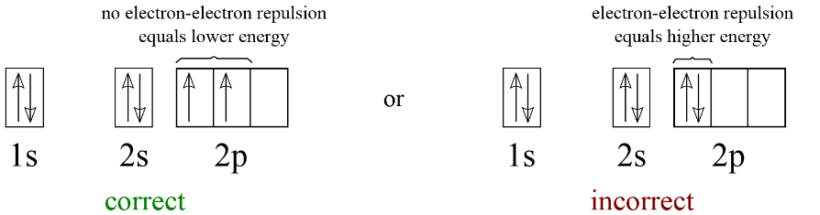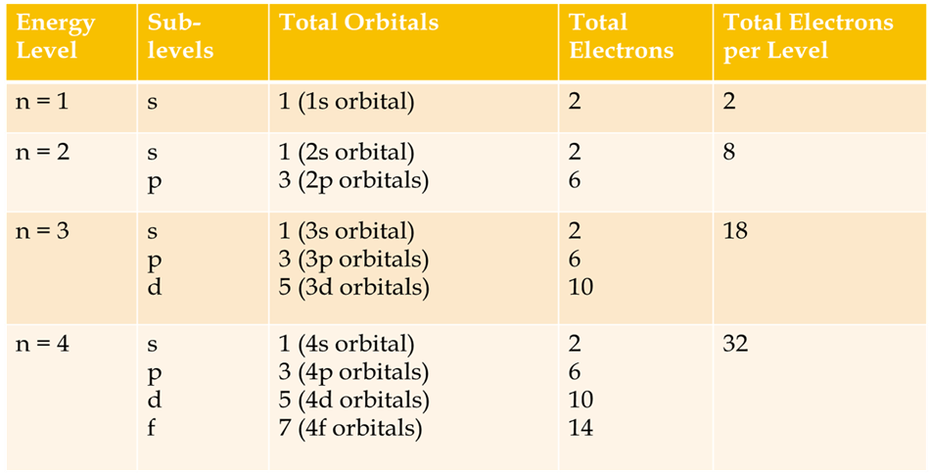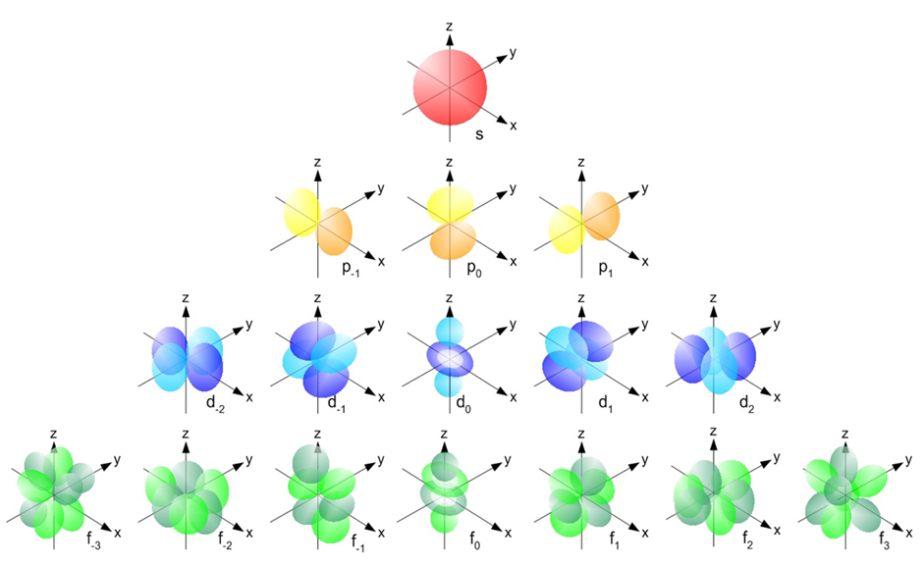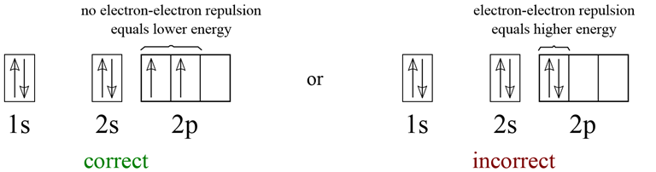

So with the 3 X 2 p orbitals, one electron will go into each orbits before any pairing occurs. Half full shells have greater stability.

**Hund's rule**

Every orbital in a subshell is singly occupied with one electron before any one orbital is doubly occupied, and all electrons in singly occupied orbitals have the same spin. **Electrons** arrange themselves in order to minimize their interaction energy. They will always occupy an empty orbital before they pair up to minimize [**repulsion**](https://www.boundless.com/chemistry/definition/repulsion/).

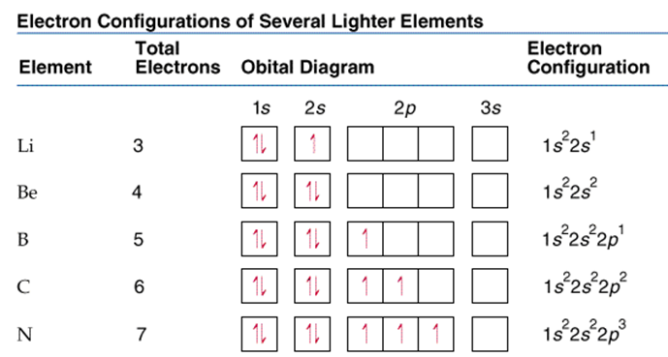

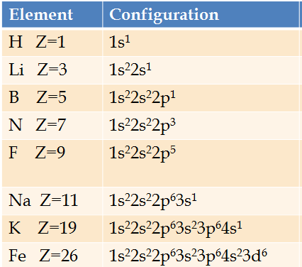**Some examples of electron configuration**

Note 4s fills before 3d according to the Aufbau principle- According to the principle, [electrons](http://en.wikipedia.org/wiki/Electron) fill orbitals starting at the lowest available (possible) [energy levels](http://en.wikipedia.org/wiki/Energy_level) before filling higher levels (e.g. 1s before 2s). Note this principle is currently under challenge due to the large number of exceptions and could change in the next few years.

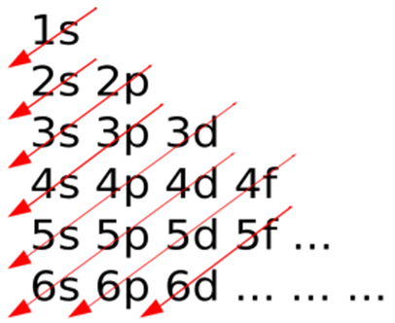

Use your periodic table to help you answer the following

1. Fill in the orbital electron representation for phosphorus. (Circles are used here but squares are often used)

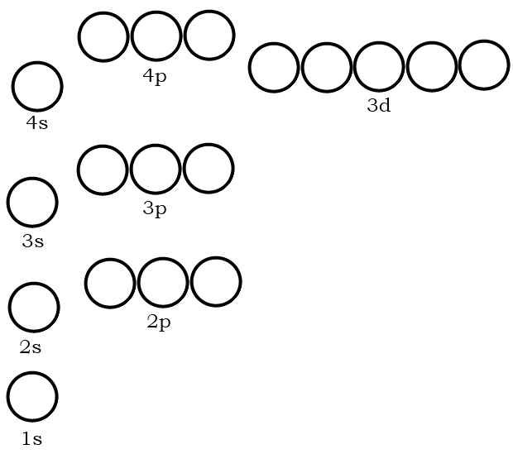

2. Fill in the electron orbital configuration for cobalt.



3. Fill in the electron orbital configuration for bromine.



4. Draw the orbital representation for the electron configuration of calcium.



5. Write the full electron configuration code for phosphorus.

6. How many valence electrons does phosphorus have?

7. Write the full electron configuration code for cobalt.

8. How many valence electrons does cobalt have?

9. Write the full electron configuration code for bromine.

10. How many valence electrons does bromine have?

11. Write the full electron configuration code for calcium.

12. How many valence electrons does calcium have?

13. How many valence electrons does tellurium have?

14. What will be the outer energy level electron configuration for element #118?

15. Draw the orbital representation of the electron configuration for silicon.



16. How many valence electrons does silicon have?

17. Write the noble gas configuration for Magnesium, Chlorine and Titanium

Questions from Oxford textbook

